

BCSE354E Information Security Management
Email Spam or Ham Classifier
Project Members:
M. Hanumantharao - 21BIT0487, S. Navaneeth - 21BIT0464, K. Vishnu kumar – 21BIT0166,
M. Yeses Chandra reddy – 21BIT0585, Sai Krishna NP – 21BIT0419

Abstract
- The "Email Spam or Ham Classifier" project is motivated by the urgent need to enhance email security, improve efficiency in email management, and provide educational and practical value in data science and Information Security.
Introduction
- Develop a Email security model to accurately classify emails as spam or ham.
- Implement a user-friendly interface for email classification.
- Evaluate the performance of the classifier using relevant metrics and real-world email datasets.

System Architecture
- Data Preprocessing and Training:
- Email Spam.ipynb: This Jupyter Notebook file is used for data preprocessing, including tasks such as data cleaning, feature extraction, and dataset exploration. It may also include data visualization to gain insights into the email dataset.
- Email Spam_with_pipeline.ipynb: This Jupyter Notebook file builds upon the preprocessing steps and incorporates machine learning pipeline creation, model training, and evaluation. It likely uses the emails.csv dataset for training and testing the email spam classifier model.
- Model Development:
- The preprocessing and model training steps in the Jupyter Notebooks result in the creation of a trained machine learning model, such as a Naive Bayes classifier, for email classification.
- Dataset Storage:
- emails.csv: This CSV file contains the dataset of emails used for analysis, preprocessing, and training. It includes email text data along with labels indicating whether each email is spam or not (ham).
- Integration with Flask Application:
- The trained model from the Jupyter Notebooks is exported or saved as a pickle file (Naive_model.pkl), as seen in main.py, for integration with the Flask application.
- The Flask application (main.py) serves as the backend that handles user input, processes it using the trained model, and displays the classification result to users through the frontend interface (index.html and show.html).
- User Interaction:
- Frontend (index.html and show.html): These files provide a user-friendly interface for users to input emails and view the classification results. They interact with the backend Flask application (main.py) to perform classification tasks.
- System Flow:
- User inputs an email in the frontend (index.html) and submits it.
- The input is sent to the Flask backend (main.py) for processing.
- The backend preprocesses the input, uses the trained model to classify the email, and sends the classification result back to the frontend (show.html) for display.
This system architecture seamlessly integrates data preprocessing, model training, dataset storage, backend development with Flask, and frontend design to create an end-to-end email spam classifier application.

Modules & Project Kit
- Languages and Frameworks:
- Python (Flask, Scikit-learn, Pandas), HTML/CSS/JavaScript (Bootstrap).
- Environment:
- Jupyter Notebooks, Geany, VS Code.
- Data:
- “emails.csv” (email dataset).
Implementation, Testing Screenshots

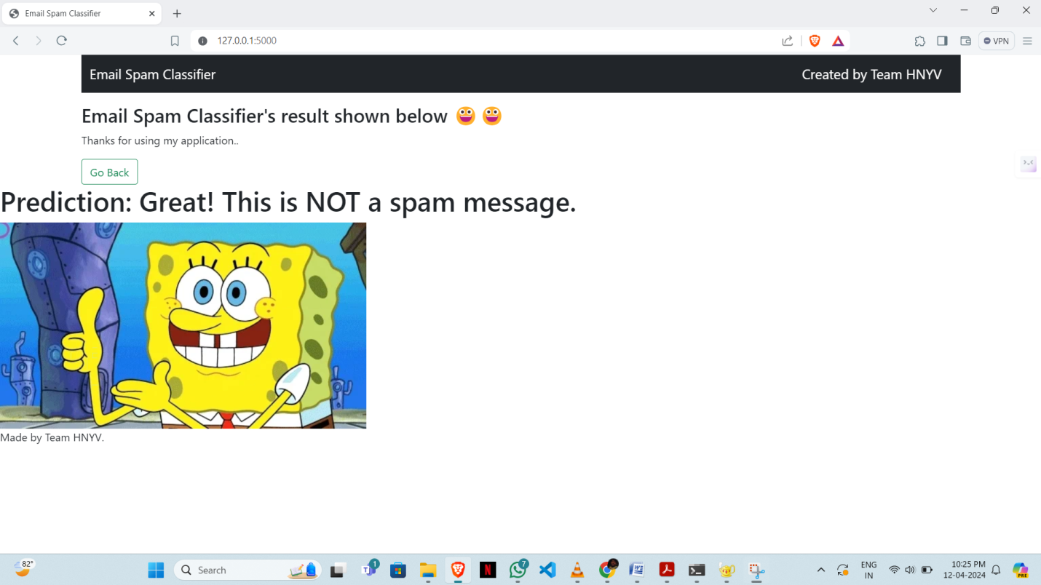
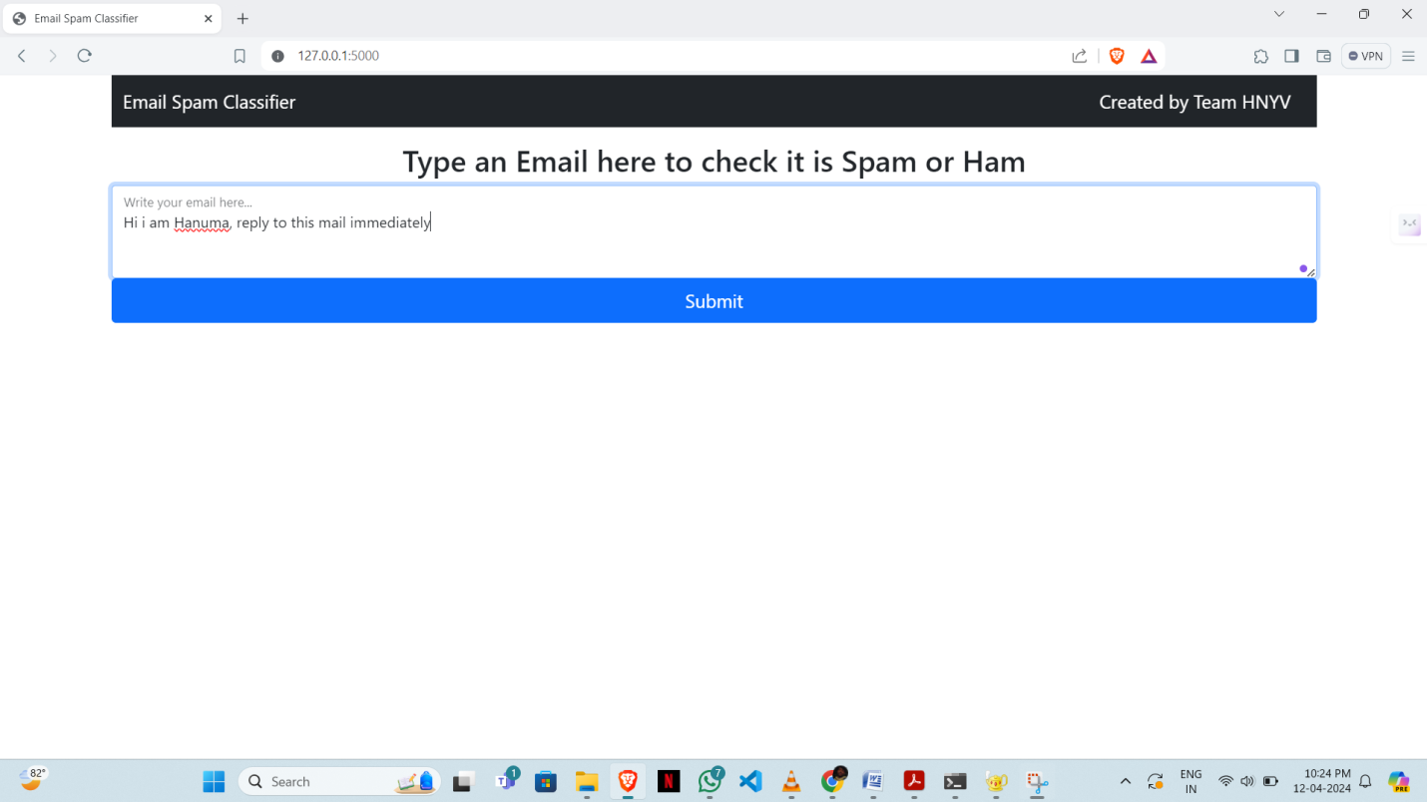

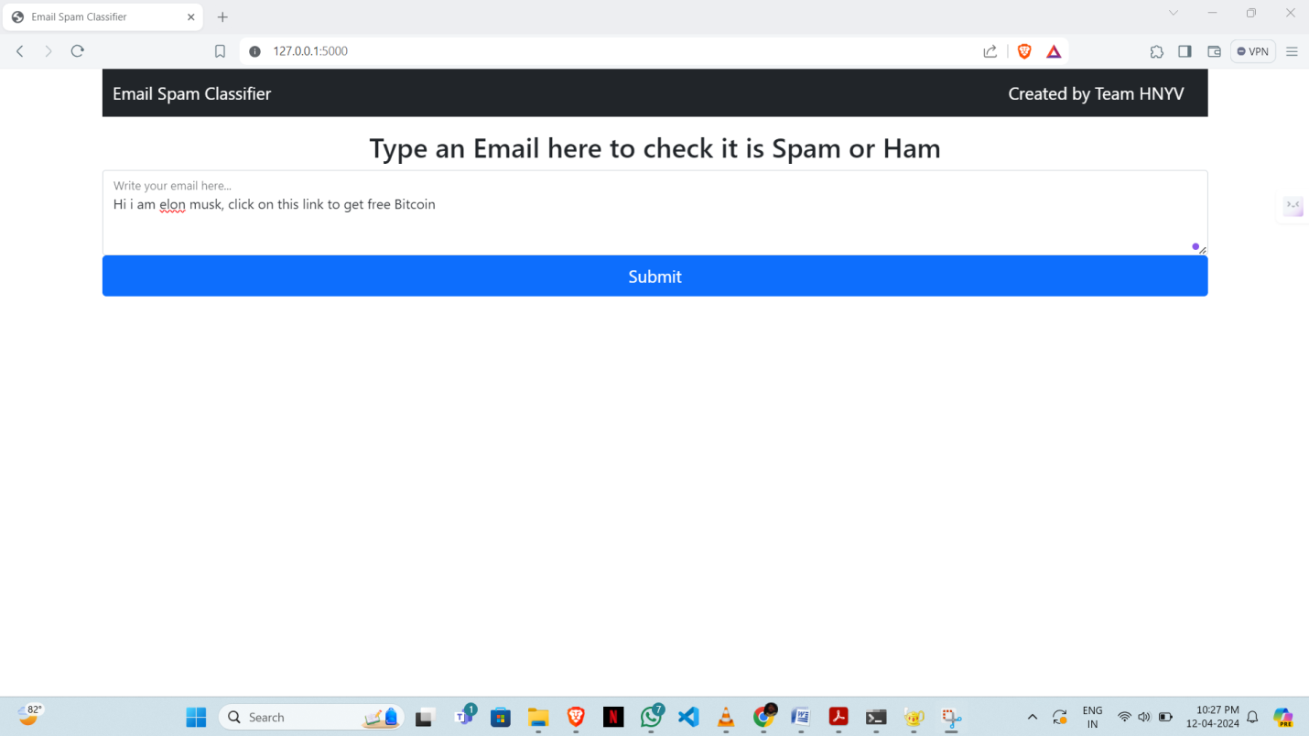

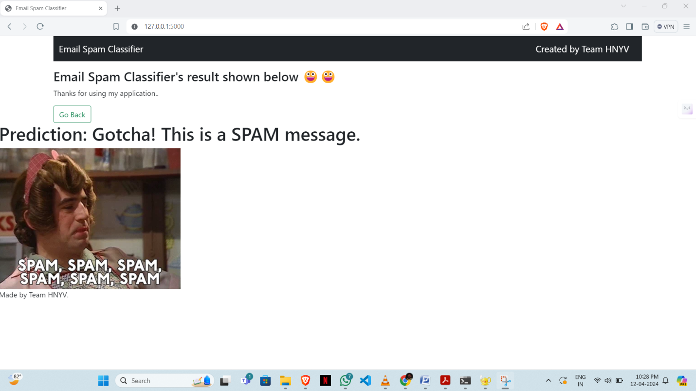

Conclusion
- The machine learning-based network/email security project successfully detected and classified threats, reduced false positives, demonstrated scalability, contributing significantly to security measures.
- It helps an user to identify some common spam emails and ham mails that are present in our dataset.
References:
https://www.cloudflare.com/learning/email-security/what-is-email-security/
https://perception-point.io/guides/email-security/types-of-email-attacks-major-attacks-and-lessons-learned/

Guided By
Faculty Name:
Dr. Mohana Priya P – SCORE
mohanapriya.p@vit.ac.in

Acknowledgements:
Thanks to VIT & SCORE

